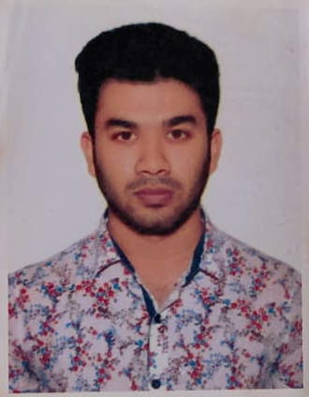
ANKON SARKER
Permanent Addres:Mithapukur,Rangpur.
Present Address: Bashundhara, Dhaka.
Mobile: 01767553784
E-mail: ankon45@gmail.com

Job Objective

Looking forward to a career where I will get the chance to use my teaching skills and knowledge in a dynamic way, through dedication and honesty.

Academic Credentials

Degree | Department/Group | Institution | Institution [Board] | Passing Year | Result
BSc | CSE | American International University-Bangladesh | Dhaka | 2019-running | 3.54
H. S. C. | Science | Cantonment Public School and Collage Rangpur | Dinajpur | 2018 | 5.00
S. S. C. | Science | Mithapukur gvt Model High School | Dinajpur | 2016 | 5.00

Award of Excellence

- Runners up in indoor Badminton Tournament-2019 at American International University-Bangladesh.

Relevant Coursework

- Data Structure
- Database
- Algorithm
- Software Engineering
- Computer Graphics
- OOP1
- OOP2

Communication and Professional Skills

- Fluent in Bangla and English both verbal and written.
- Skilled in public speaking and multimedia presentation
- Efficient in all sorts of academic and official correspondence.
- Have the ability to work independently as well as in team. Can work with people of all levels and motivate them to get things done.
- Have the ability to work under pressure/any circumstances.

Computer Skills

- Windows 98/XP/7/10, Microsoft Office 97/2000/2003/2007/2010/2013.
- Internet based research and work
- Microsoft Office.
- C, C++, Java, JavaScript, HTML/CSS.
- Graphic Design.
- Video Editing.
Referees
1. Dr. Md. Mahbub Chowdhury Mishu
Dean (Undergraduate Program)
Department of Computer Science & Engineering
American International University- Bangladesh.
mahbub@aiub.edu

2. Victor Stany Rozario.
Lecturer
Department of Computer Science & Engineering
American International University- Bangladesh.
stany@aiub.edu

I, hereby confirm that the above information is true and correct to the best of my knowledge.


(Signature)

